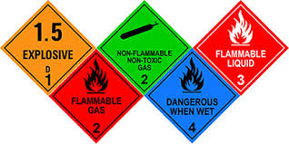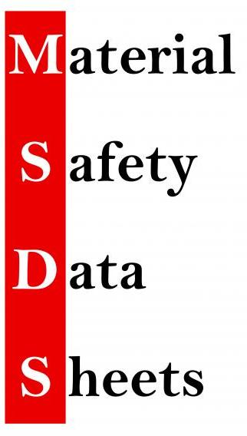

SMK BERA BANDAR 32

# CO

# NTENTS

1. Refrigerant Gas R22
2. Refrigerant Gas R134a
3. Refrigerant Gas R410A
4. Refrigerant Gas R32
5. Vacuum Pump Oil
6. Alkaline Coil Cleaner
7. Thinner
8. MAPP Gas

CONTENTS