





Timmins Training Consulting
Home
18⁺
.






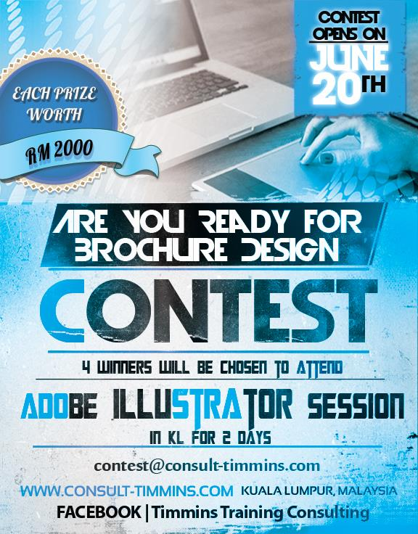
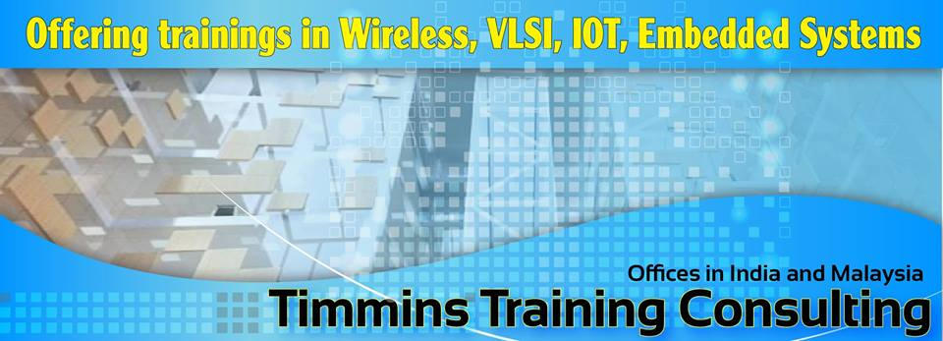
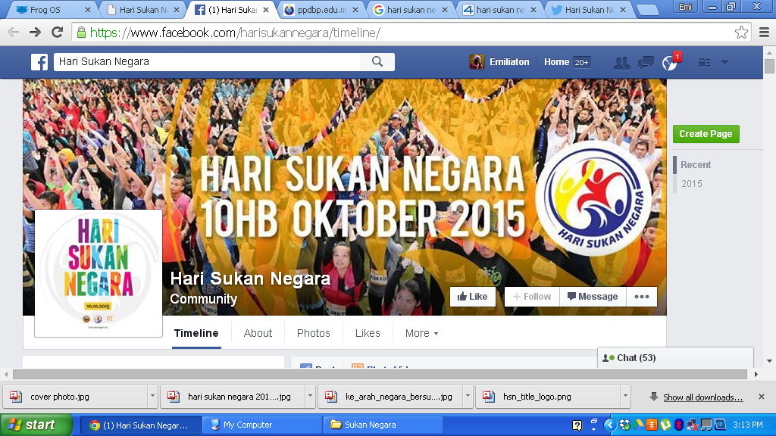

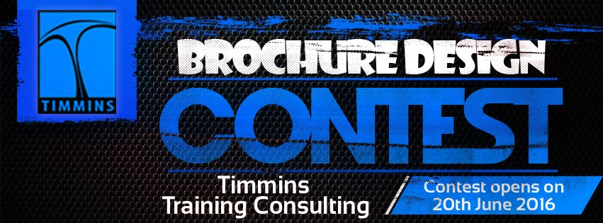
Timeline About Photos Likes More
Hari Sukan Negara
Community
Nasrul Hakim Zakaria and 623 people like this
Invite friends to like this Page
INTRODUCTION
Timmins – An Introduction
Timmins is a engineering development training company that offers Learning and Development in niche areas like Wireless, Networking, Embedded, and Systems Software. Our business ethos is “service through technical excellence” which, when combined with our technical rich independent know-how, makes Timmins the ideal training partner.
Post
Photo/Video
Write something…
Post
Timmins Training Consulting added a new photo
2 July at 09:37

Like
Comment
Share
LATEST COMING EVENT See More
PROGRAM TENTATIF

DATE: 1 AUG. 2016 – 2 AUG. 2016

TIME: 0900AM – 0500PM

COST: RM1800 PER PERSON

VENUE: KUALA LUMPUR, MALAYSIA

DURATION: 2 DAYS

DELIVERY METHOD: INSTRUCTOR LEAD & CLASSROOM

DETAILS REGISTERATION: http://consult-timmins.com/adobeindesignadv/

Adobe Indesign Advanced CS6
Hosted by Timmins
180 guests
Interested Going
TIMMINS TRAINING CALENDAR
latest sessions in k. lumpur
Like
Comment
Share
Timmins Training Consulting feeling positive
9 July at 21:14

Like
Comment
Share
Mission And Vision
Timmins believes in a controlled growth by just hand-picking technologies that are sheer next generation and niche domains. Our mantra is to “Develop rich content, Build training experts and associated with technology companies”



OUR TEAM
Timmins Training
Consulting

.
UPCOMING TRAINING CALENDAR
Timmins is uniquely positioned to offer in-depth training in niche technologies that are futuristic and next generation in nature. Our technical panelists are on forefront of technology updates as they represent Industry standard bodies like IEEE, ITU, VLSI, ESL forums.

Timmins Training Consulting added 4 new photos
23 June at 23:09

Like
Comment
Share
Like
Comment
Share






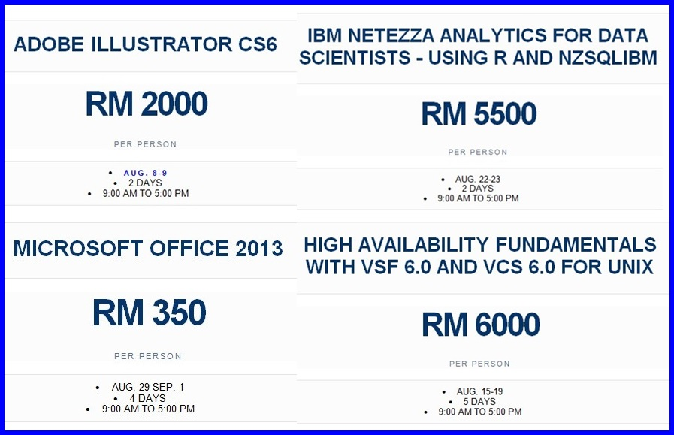
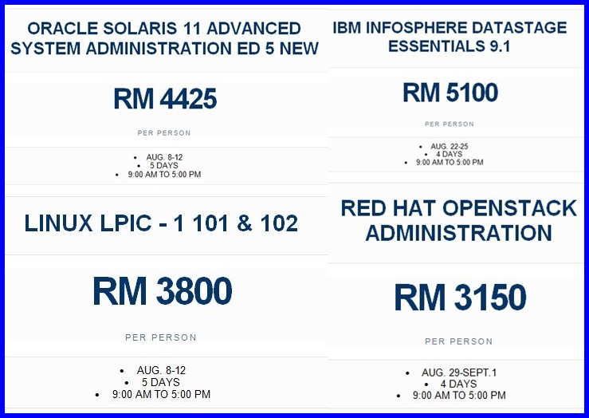
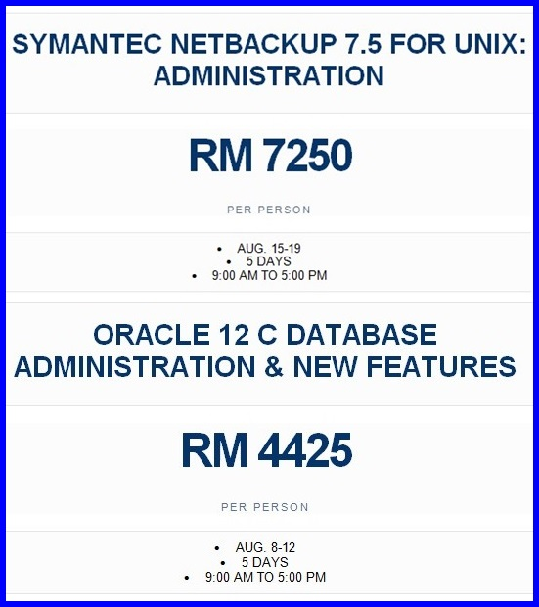
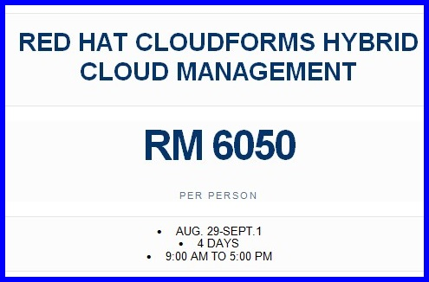
16 Ogos 2015 @ 7:30 pagi
Dataran Perhimpunan

PENGHARGAAN
Public Hosted by Timmins
03 2785 0737 (Office)
+60 11 3529 5347 (Mobile)
Timmins Training Consulting
A27-07 Mercu Summer Suite 8, Jalan Cendana, 50250 Kuala Lumpur Show Map

With a pool of training companies out there in the global market, there are many general purpose trainings in the offering. It’s practically hard for the clients, vendors to discern and distinguish who are adept in these domains.

As a framework, Timmins connects with academia (Top schools) on theoretical research and also blends it with Industry on what prospective technologies are due for future, coming up with structured trainings that looks promising for future. Timmins Consulting would offer trainings in multimode: Webinars based, In-person faculty, Workshop, Seminars, Lab based practical – A framework that should be technical enriching to the engineering community as a whole.

OUR SOLUTIONS
BRIDGING ACADEMIA AND INDUSTRY INDUSTRYYTAGLINE
“Tailor-made expert trainings”
raj@consult-timmins.com
www.consult-timmins.com
Like
Comment
Share

